1. Write a Python program to print "Hello Python"?

*print("Hello Python") #Double quote*

*print('Hello Python') #Single quote*

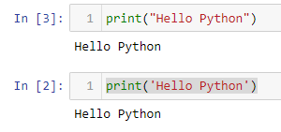

1. Write a Python program to do arithmetical operations addition and division.?

***#Addition***

*In Python, + symbol is used for additional operator. It is used to add two values.*

*a=2 #value 2 is assigned to variable a*

*b=3 #value 3 is assigned to variable b*

*c=a+b # using + operator for addition and stored the value in variable c*

*print(c)*

***#Division***

*In Python, + symbol is used for additional operator. It is used to division two values.*

*a=2 #value 2 is assigned to variable a*

*b=3 #value 3 is assigned to variable b*

*c=a/b # using / operator for division and stored the value in variable c*

*print(c)*

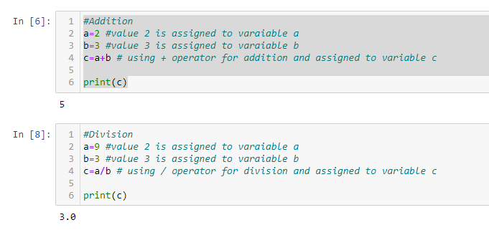

1. Write a Python program to find the area of a triangle?

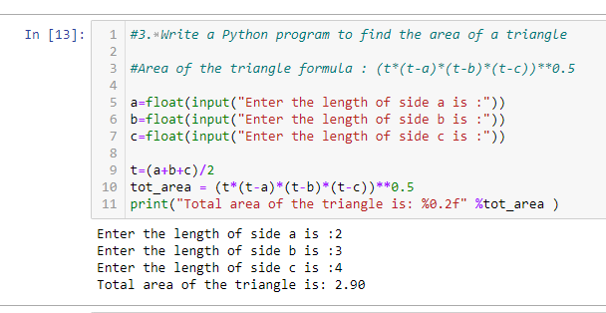

1. Write a Python program to swap two variables?

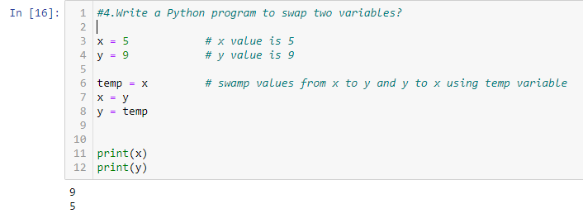

1. Write a Python program to generate a random number?

